**DAILY ONLINE ACTIVITIES SUMMARY**

|  |  |  |  |  |  |  |  |  |
| --- | --- | --- | --- | --- | --- | --- | --- | --- |
| **Date:** | **07-06-2020** | | | | | **Name:** | **Apeksha Rane** | |
| **Sem & Sec** | **6th&A** | | | | | **USN:** | **4AL17CS010** | |
| **Online Test Summary** | | | | | | | | |
| **Subject** | | **System software and compiler design.** | | | | | | |
| **Max. Marks** | | **30** | | **Score** | | | **22** | |
| **Certification Course Summary** | | | | | | | | |
| **Course** | **INTRODUCTION TO FULL STACK DEVELOPMENT.** | | | | | | | |
| **Certificate Provider** | | | Greatlearning  Academy | | **Duration** | | | 10hours |
| **Coding Challenges** | | | | | | | | |
| **Problem Statement:** 1.write a java Program to print smallest and biggest possible palindrome word in a given string.  2. Python program the first and last 5 elements. | | | | | | | | |
| **Status: Done** | | | | | | | | |
| **Uploaded the report in Github** | | | | | **YES** | | | |
| **If yes Repository name** | | | | | <https://github.com/Apeksha12appu/19-5-2020-online-coding-activity> | | | |
| **Uploaded the report in slack** | | | | | **YES** | | | |

Online Test Details:

Subject:-**System Software and compiler design.**

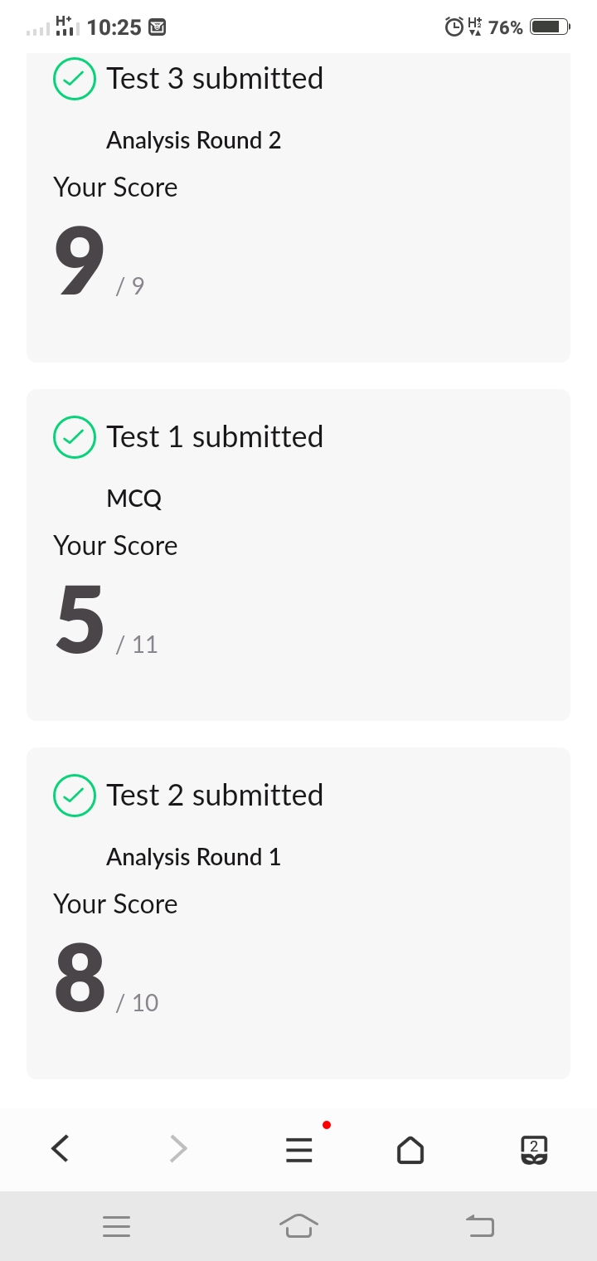

Certification Course Details:

**INTRODUCTION TO FULL STACK DEVELOPMENT.**

Today I have studied :

* Tables1.
* Tables1 assignment.
* Tables2.
* Tales2 assignment.
* Introduction to forms.
* Introduction to forms quiz.
* Introduction to input elements.
* Introduction to input elements quiz.
* More on Input elements.
* More on input elements quiz.

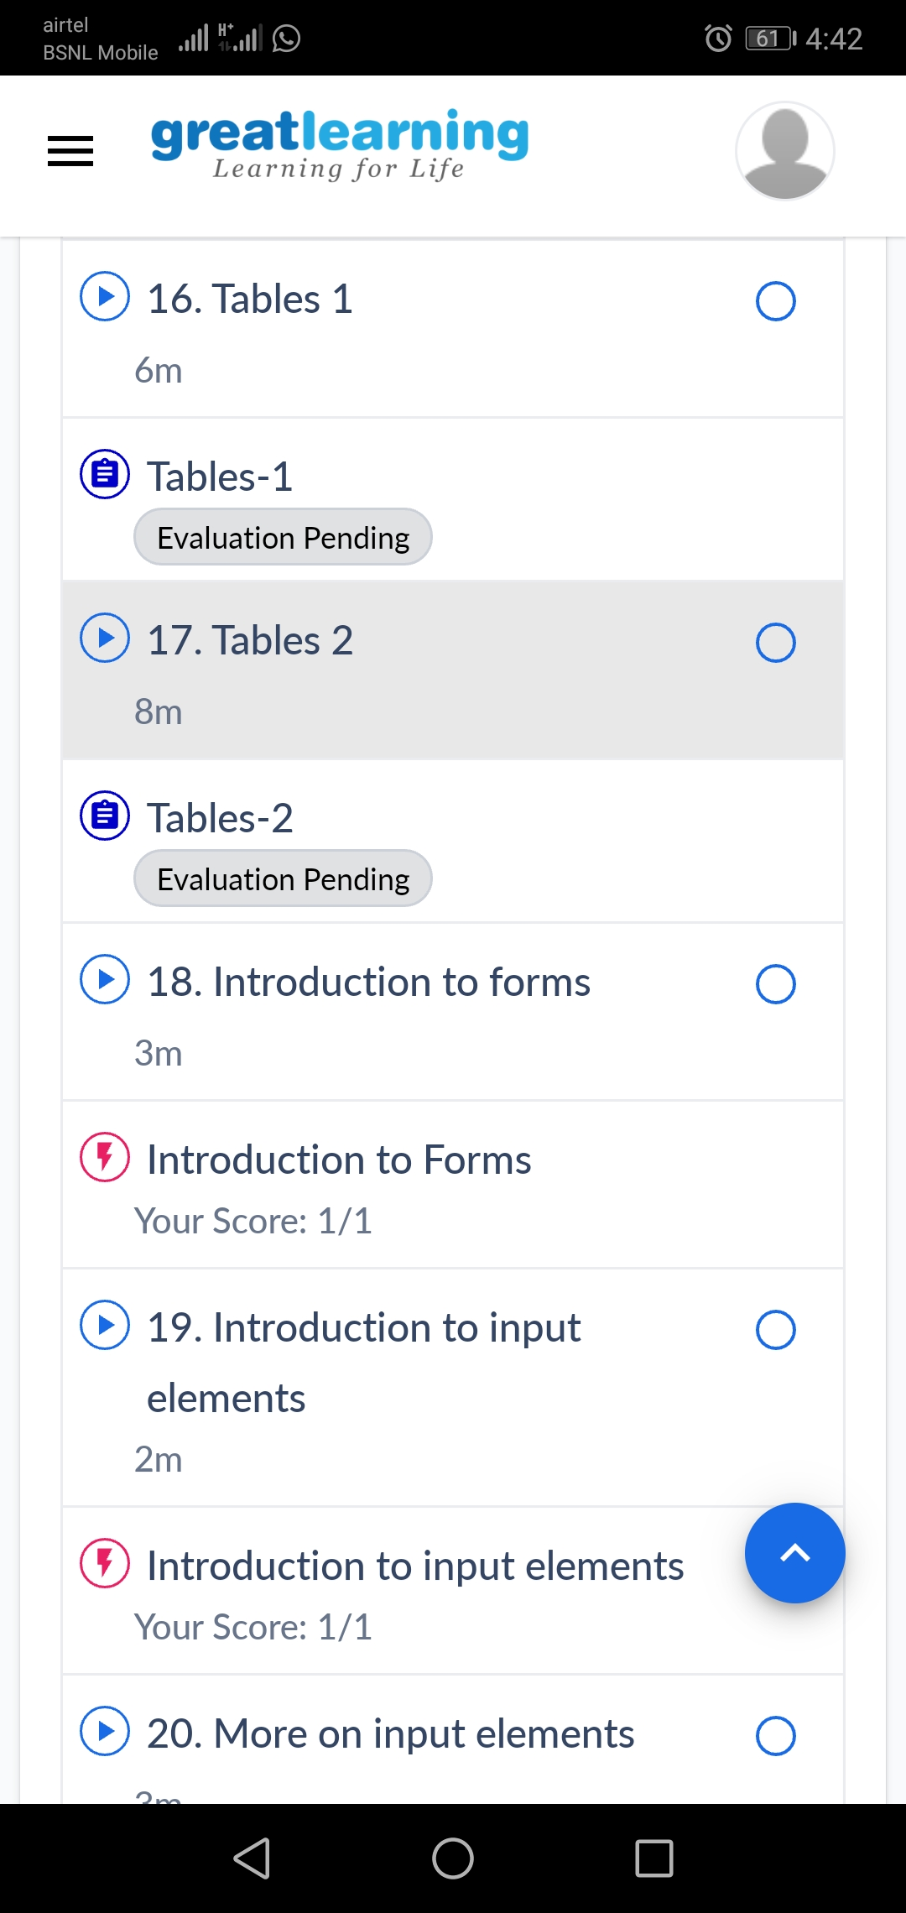

Coding Challenges Details:

1.write a java Program to print smallest and biggest possible palindrome word in a given string

public class Main

{

    public static boolean isPalindrome(String a){

        boolean flag = true;

        for(int i = 0; i < a.length()/2; i++){

            if(a.charAt(i) != a.charAt(a.length()-i-1)){

                flag = false;

                break;

            }

        }

        return flag;

    }

    public static void main(String[] args){

        String string = "Wow you own kayak";

        String word = "", smallPalin = "", bigPalin="";

        String[] words = new String[100];

        int temp = 0, count = 0;

        string = string.toLowerCase();

        string = string + " ";

        for(int i = 0; i < string.length(); i++){

            if(string.charAt(i) != ' '){

                word = word + string.charAt(i);

            }

            else{

                words[temp] = word;

                temp++;

                word = "";

            }

        }

        for(int i = 0; i< temp; i++){

            if(isPalindrome(words[i])){

                count++;

                if(count == 1)

                    smallPalin = bigPalin = words[i];

                else{

                    if(smallPalin.length() > words[i].length())

                        smallPalin = words[i];

                    if(bigPalin.length() < words[i].length())

                        bigPalin = words[i];

                }

            }

        }

        if(count == 0)

            System.out.println("No palindrome is present in the given string");

        else{

            System.out.println("Smallest palindromic word: " + smallPalin);

            System.out.println("Biggest palindromic word: " + bigPalin);

        }

    }

}

Output:

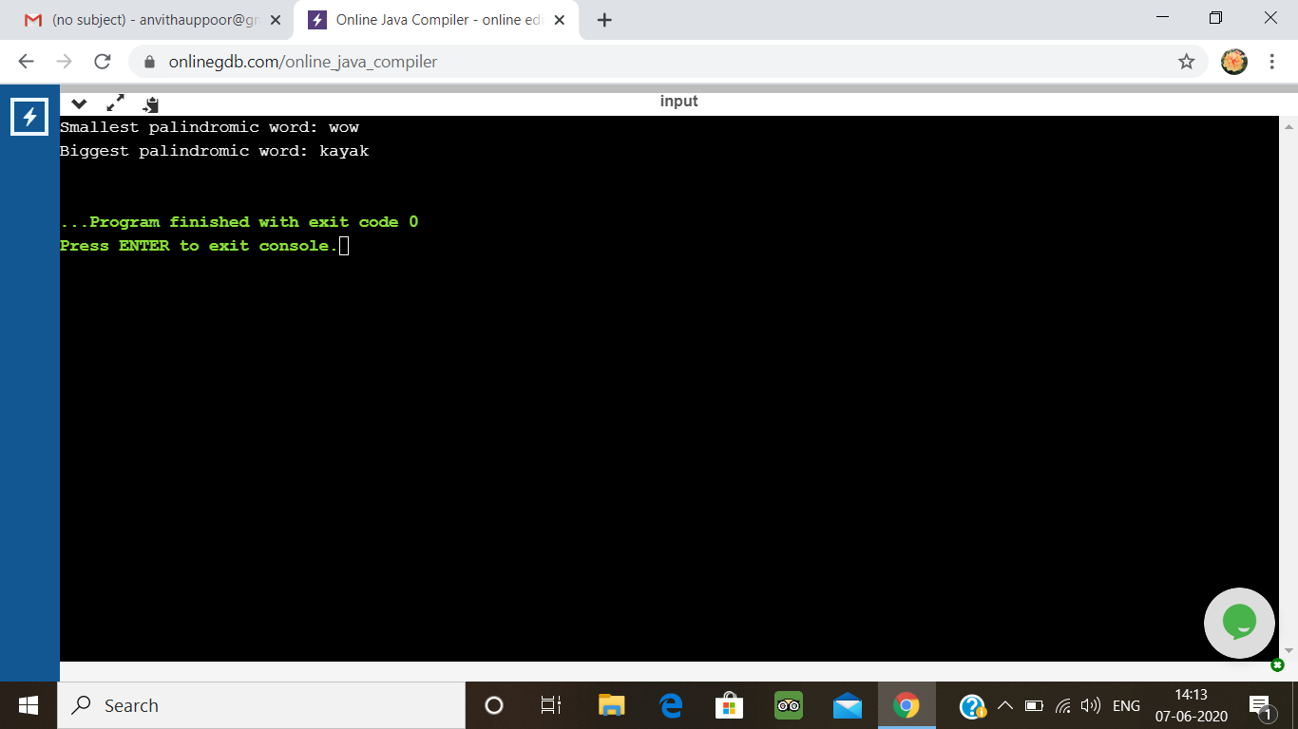

2. Python program the first and last 5 elements

Description:  
Print a list of first and last 5 elements where the values are square of numbers between 1 and 30 (both included)

Eg: If the range of elements is 20  
Then output is:  
[1,4,9,16,25]  
[256,289,324,361,400]  
If the elements begins from 5 to 30  
Then output is:  
[25,36,49,64,81]  
[676,729,784,841,900]

def printValues():

l = list()

for i in range(1,20):

l.append(i**2)

print(l[:5])

print(l[-5:])

printValues()

**output:**

